**Power BI Dashboard Report**

**M S Dhoni ODI Performance Index Dashboard**

**Dashboard Analysis Questions:**

Problem 1: Analysis of MS Dhoni's top 5 ground performance in a year 2008?

Problem 2: Analyze MS Dhoni's batting performance data and display exceptional monthly and quarterly performances throughout the year.

Problem 3: In which opposition team did MS Dhoni have the top 5 batting performances in 2013?

Problem 4: How many cricket matches did MS Dhoni play for India in 2008, 2011, 2013, 2017, and 2018?

Problem 5: Show the records of MS Dhoni's maximum runs, total sixes, total fours, opponents matched, total runs, and average run rate.

**Dashboard Output:**

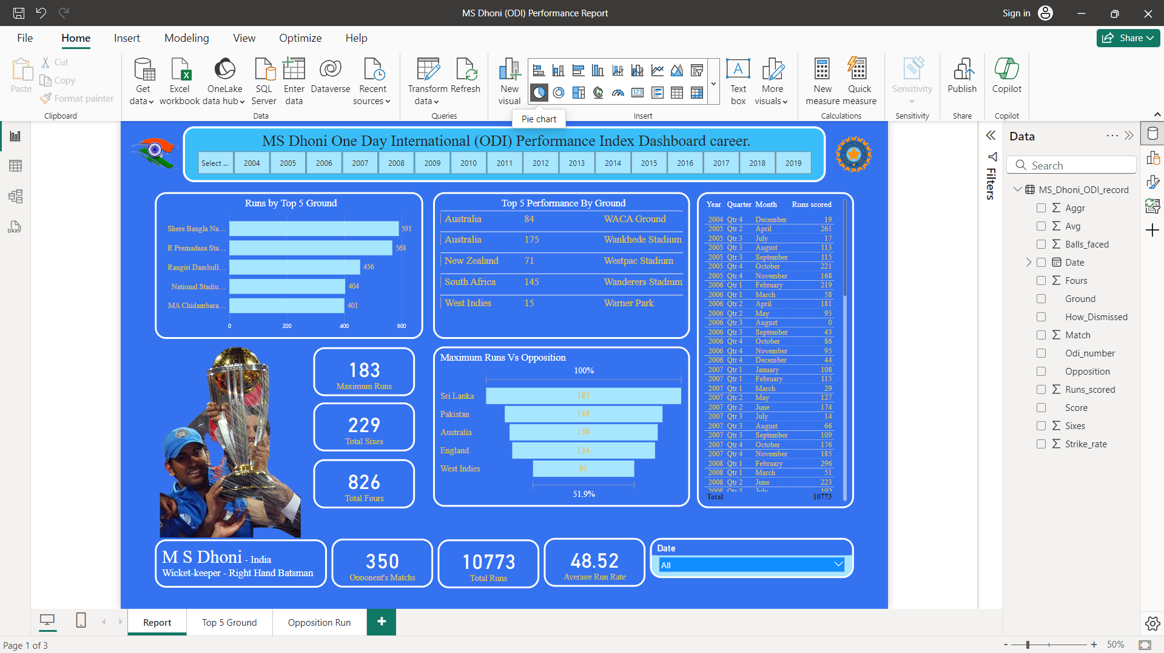

Problem 1: Analysis of MS Dhoni's top 5 ground performance in a year 2008?

Problem Output 1: Runs By Top 5 Grounds

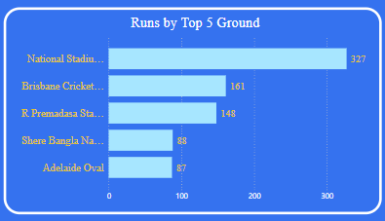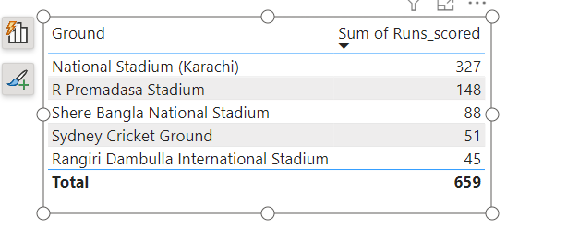

Problem 2: Analyze MS Dhoni's batting performance data and display exceptional monthly and quarterly performances throughout the year.

Problem Output 2: Performance by Monthly & Quarterly

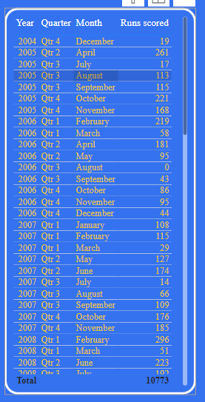

Problem 3: In which opposition team did MS Dhoni have the top 5 batting performances in 2013?

Problem Output 3: Maximum Runs Vs Opponent Team in the Year 2013

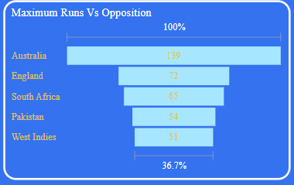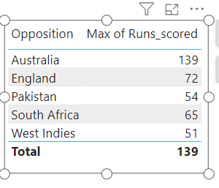

Problem 4: How many cricket matches did MS Dhoni play for India in 2008, 2011, 2013, 2017, and 2018?

Problem Output 4: Total number or Match in the year

2008: Opponent’s Match’s = 29

2011: Opponent’s Match’s = 24

2013: Opponent’s Match’s = 26

2017: Opponent’s Match’s = 29

2018: Opponent’s Match’s = 20

Problem 5: Show the records of MS Dhoni's maximum runs, total sixes, total fours, opponents matched, total runs, and average run rate.

Problem Output 5: Maximum Runs, Total Sixes, Total Fours, Opponents Matched, Total Runs, And Average Run Rate.

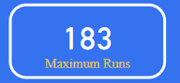 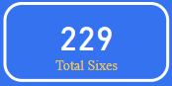 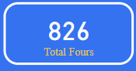

 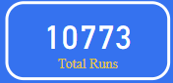 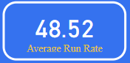

**Power BI Dashboard Preview:**

